Product Requirements Document

**-Business Services- Businesses-**

**Enhancing the construction process**

**Author:** Raju Roy

**Change History:**

Updated on: July 25, 2021

First Draft: July 2, 2021

**Overview:**

Study shows that the construction industry had been underperforming for over past 20 years. **Risk aversion, COVID-19,** **and fragmentation** as well as difficulties in attracting **digital** **talent** has slowed down innovation. Despite taking high risks and many insolvencies, the industry has seen a low profit rate at around 5% EBIT margin.

Alongside, both the **contractors** and the **workers** are getting affected by this. Contractors are facing difficulties in finding eligible workers who could handle *new materials, technology, and methods*. On the other hand, finding jobs for the workers have always been a major problem in this industry.

The vision is to build a platform to help *bridge* the gap between the contractors and the workers. It would help contractors get skilful and experienced labours easily and help workers get more employment. The product would analyse and try to solve each major problems faced by our users.

**Goals:**

1. To provide a **platform** for contractors to bid and hire workers.
2. Provide fixed and *digitized* payments on the product.
3. For workers, provide **heat** maps for detecting job sites.
4. Include ‘Message’ feature for worker-contractor interaction.
5. ‘Bidding’ system for contractors.
6. Learn to adopt new technology.

**Success Metrics (KPIs):**

“If we fix these problems early, they’re cheaper to fix. If we start with a **$25** issue that could be fixed in design, if that gets to construction, that increases to **$250** to fix. If it’s spotted during snagging that will be **$2,500**. If it gets into operation, it could cost **$250,000**. Knowing where the issues are early on is essential.”

* **Input Metrics:**
  + Design defects: Better understanding of the total quality of projects may help reduce changes and rework.
  + **Site** inspection to prevent any delays.
  + Pending Bids
  + Incident rate/Safety at onsite: Safer site would incur less risk and long-term costs.
* **Output Metrics:**
  + Revenue Generated
  + **Churn** Rate: a good churn rate comes largely when we understand better the needs of our customer. Maintaining a healthy base of happy customers should be the key for our growth in this business.
  + Training completion percentage
  + Customer satisfaction: Tracking workers performance is crucial for a successful project, which includes their satisfaction. Happier staff tend to work more efficiently in a long-term run.

**Technologies:**

* **Geolocation:** Projects must not get delayed due to inaccurate onsite ground conditions. Techniques like high-definition photography, 3-D laser scanning, and geographic information systems can be used to improve accuracy and speed.
* **Data Collection:** This can help to gather more accurate and quality data at a faster rate. Also, it can help in *safety* and save *time*.
* **Artificial Intelligence:** This would provide benefits like *improving workflow*, and getting jobs done at a faster rate.
* **Virtual Reality technology/ Augmented reality:** Virtual reality (VR) implies a complete immersion experience that shuts out the physical world, whilst augmented reality (AR) adds digital elements to a live view. Here, we can use benefits like **virtual tours** of finished building models to better understand the design. This would enhance collaboration and analyse potential risks.
* **Cloud technology:** This would enable the possibility to access, use, modify, exchange, administer and manage data stored in remote servers, by using appropriate software applications. This would allow **data sharing**, from the construction sites in real-time to all entities participating in the building construction process or to other entities responsible for contract realisation.
* **Blockchain Technology:** Blockchain is digital information stored in transactional public database (block), that is peer-to-peer controlled or verified by network of computers (chain) without interference of any central authority. This has potential to establish error-free process for contracts generation, administration, and monitoring. Also, it does increase efficiency and excludes the intermediary parties and their services. It encourages more collaborative working and contributes to timely decision-making with minimising the risk and avoiding disputes.

**Constraints:**

* **Design Constraints:** Budget, Site access, performance requirements, climatic conditions, available technologies.
* **Legal Constraints:** Employment law, safety requirements, building regulations, etc. Failing to comply with legal requirements may cause delays and financial penalties.
* **Environmental Constraints:** Use of sustainable materials, pollution, transport, climate change and energy consumptions.

**User Persona:**

**Construction workers** and **contractors** would be the ideal customers for the product.

There has been a lack of proper interaction between both. Study indicates that about **21%** of employees in the construction industry are of age 50 or older, compared to just **9%** that are 24 or younger, which is causing issues in meeting the current growing demands. Current measurements find that there has been a consistent *decline* in the industry’s productivity since the late **1960s.**

This needs to be glue together properly to uplift the construction industry which has not been able to see its rise which is at a similar level as it was **80** years ago.

Workers are unable to find new jobs as per their skillset and contractors are facing huge difficulty to find more eligible workers.

For *less* skilled workers, newer trends and latest technology needs to be introduced to them.

**Industry landscape:**

**‘Bandhoo’**

* **Hiring Module**- Reaches out to workers based on skills, location, and wage-rates.
* **Project Monitoring module**- To track metrics, workers, progress, and productivity.
* **Tender Module**- Helps reach out the sub-contractor specialized in various skill set.
  + **Workers** registered: 35013
  + **Contractors** registered: 7038
  + **Tenders** published: 543

**Link** for the website: <https://bandhoo.com/>

**Problems** they try to solve:

* How do we find a couple of find good finishing contractors?
* Where can we find another 5 plumbers to speed things up?
* Can we better the labour productivity?
* Finding bottlenecks that do slow down the project.

**Features** available on this product:

* Contractor can register with details and can post jobs with requirements for various positions. Workers can also register for this product, provide qualification details, and find new jobs.
* Contractors can make an offer to the eligible candidates and negotiate, thereby complete the hiring process.
* Bidding system.

**Use Cases/Features:**

* **Wireframes:**
  + Registration:

* + Profile Page:

* + Homepage:

* + Sidebar Menu:

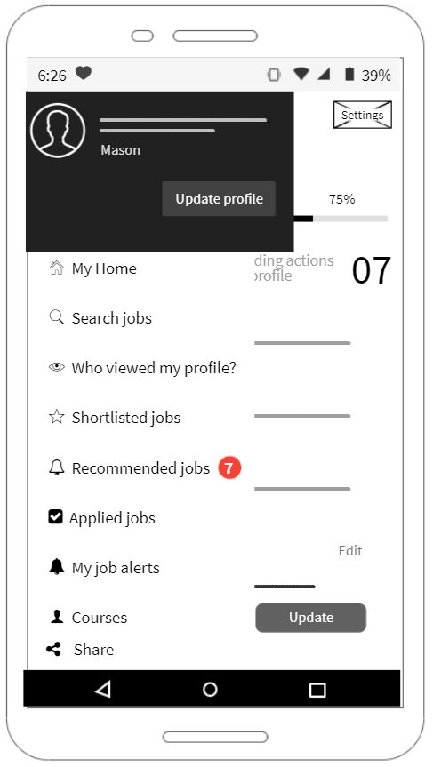

* + Bidding for contractors:

**Potential Risks:**

**‘RAID’** framework:

* **Risks**:
  1. Worker safety especially due to the current pandemic
  2. Cyberattacks
  3. Lack of a proper systematic review.
* **Assumption**:
  1. Choosing good **KPI**s
  2. Easy migration of workers to their respective workplace
  3. Adopt **‘automations**’ to increase *productivity*, not thinking if it would replace the workers by robots.
* **Issues**:
  1. Underqualified Labors who are less able to adapt to newer technologies.
* **Dependencies**:
  1. Raw materials
  2. Government laws, regulations, and policies
     + This may help reshape regulatory environments by streamlining permitting and approvals processes, reducing informality and corruption, and encouraging transparency on cost and performance; and may allocate grants for innovation and training.

**Roadmap (more to work on it):**

Data collected from sources are stored in a database which later needs to be cleaned and processed. We can apply machine learning to explore for safety analysis, weather reports and other features.

**Release Criteria (to be updated):**

**Business Case Summary:**

Workers do face difficulty in finding suitable jobs. On the other hand, contractors fail to hire eligible and talented workers due to location, skills, etc.

We tend to help the workers by showing **heat maps** around/farther from their locations. Contractors can post jobs with rates and other requirements to which workers can apply. Bidding system has also been added.

Workers with *less* skill can learn courses from here at a minimal cost for which on completion, they get a **certificate**. They can use it apply for jobs here.

Risks like cyberattacks, worker safety, raw materials, lack of systemic review and government polies around the region may affect project deadlines.

Workers now can search for jobs at their fingertips, just need to work on their skillset.

Better customer feedbacks can help increase sales, impact the KPIs and increase revenue. Revenue can be achieved from ads and premium version of the product.

Investments like storing data in databases and on people/engineers for different roles in this product.

**Executive Summary:**

**Vision**: To reduce the gap provide a platform for workers and contractors for the benefit of the two.

**Objectives**: Use *geolocation* data to show heatmaps for workers, establish secure payment option for daily wage rates of workers, **bidding** feature for contractors to submit the tender, use **AI** technology to find best jobs, use **VR** for virtual tour of the final project.

**Risks**: Government laws/policies, availability of raw materials, data privacy/security, cyberattacks and safety of workers.

**References:**

* <https://www.mckinsey.com/business-functions/operations/our-insights/improving-construction-productivity>
* <https://www.mckinsey.com/~/media/McKinsey/Business%20Functions/Operations/Our%20Insights/Voices%20on%20Infrastructure%20Workforce%20of%20the%20Future/GII-Voice-Dec-2019.pdf>
* <https://constructionblog.autodesk.com/construction-kpis/>
* <https://www.mckinsey.com/industries/private-equity-and-principal-investors/our-insights/rise-of-the-platform-era-the-next-chapter-in-construction-technology#>
* <https://constructionblog.autodesk.com/predictive-analytics-construction/>
* <https://www.thebalancesmb.com/how-the-construction-industry-is-using-big-data-845322>
* <https://www.mckinsey.com/~/media/McKinsey/Industries/Capital%20Projects%20and%20Infrastructure/Our%20Insights/The%20next%20normal%20in%20construction/The-next-normal-in-construction.pdf>
* <https://bandhoo.com/>